
云南大学软件学院期末课程报告
Final Course Report
School of Software, Yunnan University

个人成绩
学号 | 姓名 | 专业 | 成绩
20243120018 | ROY SUDIPTA | SOFTWARE ENGINEERING

学 期：3RD Semester
课程名称:Professional Training -YN3012170034
任课教师: Ahamad Zahir
题目: A Containerized RAG Architecture for Efficient Document Retrieval using BGE Embeddings and Qdrant
联系电话: 13170632019
电子邮件:shudiptoroy6@gmail.com
报告完成时间： 2025 年 12 月 11 日

An efficient Document Retrieval Containerized RAG Architecture with BGE.
Author: ROY SUDIPTA
Yunnan University

Abstract:
This project develops a Retrieval Augmented Generation (RAG) application, which allows an us to upload PDF files, search through them with the help of semantic similarity, and receive an answer based on a context retrieved only. I have deployed a transformer based embedding model in the system to transform text chunks into vectors. It caches such vectors in Qdrant, a similarity search optimized vector database. For generation the system is calling out from locally hosted LLM server (Ollama) which-season stream the answer to UI for real-time experience. The complete solution is running in containers with the multi service setup, among them the application container (FastAPI app + Streamlit UI), the vector storage (Qdrant), and the local inference (Ollama container). The project provides an end-to-end NLP pipe with PDF extraction, text splitting, the generation of embeddings, storage of the vectors, search on vectors, building of prompts, and streaming of responses.

Github: https://github.com/Shudipto-creator/A-Containerized-RAG-Architecture-for-Efficient-Document-Retrieval-using-BGE-Embledings-and-Qdrant

Contents Page
- Introduction-----------------------------------------------------------------------------------------03
1.1 Motivation---------------------------------------------------------------------------------------03
1.2 Background (NLP, Deep Learning, Transformers, RAG) ---------------------------------03
1.3 Why embeddings and vector search matter-----------------------------------------------03
- Literature Review------------------------------------------------------------------------------------03
2.1 Semantic search systems---------------------------------------------------------------------03
2.2 Transformer based encoders for embeddings---------------------------------------------03
2.3 Vector databases and similarity search----------------------------------------------------03
2.4 LLM serving frameworks (local LLM via Ollama) ------------------------------------------04
- System Design---------------------------------------------------------------------------------------04
3.1 High level architecture-------------------------------------------------------------------------04
3.2 Data and preprocessing workflow-----------------------------------------------------------05
3.3 Embedding generation design----------------------------------------------------------------05
3.4 Container / Deployment Topology (Docker Compose Mental Model)-------------------06
3.5 Container architecture (services and networking) ----------------------------------------07
- Implementation---------------------------------------------------------------------------------------07
4.1 Repository structure-----------------------------------------------------------------------------07
4.2 Backend API implementation (FastAPI)-------------------------------------------------------08
4.3 Document ingestion pipeline (PDF, chunking, embedding, upsert)----------------------09
4.4 Query pipeline (embedding, vector search, prompt building, streaming LLM answer)- 11
4.5 Frontend UI implementation (Streamlit)-------------------------------------------------------13
4.6 Dockerization (Dockerfile, compose design)--------------------------------------------------13
- Results and Evaluation--------------------------------------------------------------------------------14
5.1 Example queries and outputs--------------------------------------------------------------------14
5.2 Performance observations (latency breakdown)----------------------------------------------15
5.3 Retrieval quality checks---------------------------------------------------------------------------15
- Discussion------------------------------------------------------------------------------------------------15
6.1 Challenges and issues-----------------------------------------------------------------------------15
6.2 Why containerization helped----------------------------------------------------------------------16
6.3 Tradeoffs and limitations---------------------------------------------------------------------------16
- Conclusion and Future Work---------------------------------------------------------------------------16
- References-----------------------------------------------------------------------------------------------16
- Appendix------------------------------------------------------------------------------------------------16

1. Introduction
1.1 Motivation
This project aims at filling that gap by developing a semantic search and question answering workflow. The user uploads PDFs, indexed by the system as embeddings whereby the system retrieves pertinent chunks during querying time and produces an answer based on the relevant chunks.
1.2 Background (NLP, Deep Learning, Transformers, RAG)
Transformer models are frequently used in modern NLP systems since they are capable of capturing context, as compared to older bag of words systems. Transformer encoders output dense embeddings, with semantically close texts having vectors that are similar, to be used during search and retrieval.
RAG combines retrieval and generation: It retrieves the most relevant text chunks from a knowledge base, build a prompt using only retrieved context, generate an answer using an LLM, This reduces hallucination risk compared to asking an LLM with no context.
1.3 Why embeddings and vector search matter
Embeddings turn text into numbers. Vector search lets us find “meaning level” similarity rather than exact word overlap.
Key benefit: the system can answer with citations from the uploaded PDFs, even when the user’s wording does not match the PDF wording.
2. Literature Review
2.1 Semantic search systems
The conventional IR systems (TF IDF, BM25) are based on overlapping words. Semantic search involves the use of embeddings to understand the meaning. This tends to enhance the recollection of the paraphrases and synonyms.
2.2 Embedding based transformer based encoders.
There are Sentence Transformers, which are mostly used for the fast generation of embedding. They are contrastively-trained transformer encoders whose objectives include contrastive learning style, where semantically similar sentences are close to each other in the vector space. The embedding model is loaded only once in this project and it is reused which optimizes the throughput and minimizes memory churn.
2.3 Vector databases and similarity search
Vector databases are used for storing the embeddings and for the approximate nearest neighbor search. Qdrant, used in storage, stores vectors as well as metadata and it has the ability to filter based on metadata, which is the focus of this analysis, as the user can decide on which PDFs are uploaded and searched. 3.4 Frameworks of serving LLM (local LLM using 2.2 Llama)
2.4 LLM serving frameworks (local LLM via Ollama)
A local inference server lets the project run without sending documents to external APIs. That fits privacy and offline use. It also keeps the architecture realistic for production style deployments where services communicate over a network.
3. System Design
3.1 Architecture Diagram
There are three services running within the system:
- Application service: FastAPI API for upload and query, plus Streamlit UI
- Vector database service: Qdrant stores embeddings and metadata
- LLM service: Ollama is an HTTP API chat capable model.
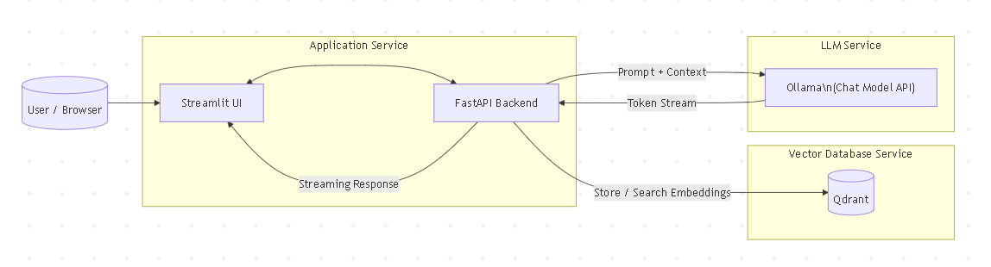
Data flow:
3.2 Data Flow Diagram (Upload → Query → Answer)
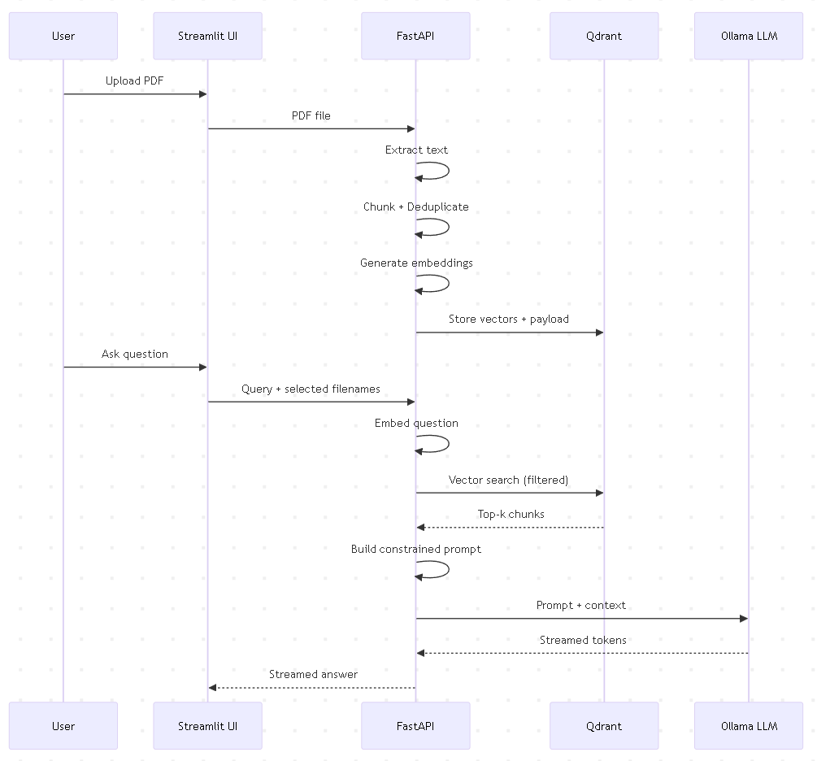

3.3 Query Pipeline
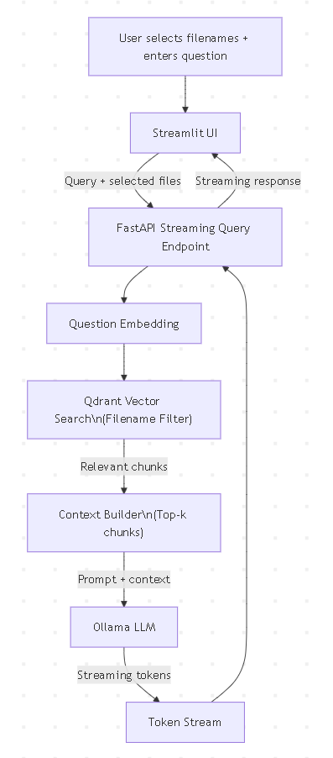
A key design choice is to use a singleton model loader so the embedding model is loaded once and shared across requests.
  - Container / Deployment Topology (Docker Compose Mental Model)
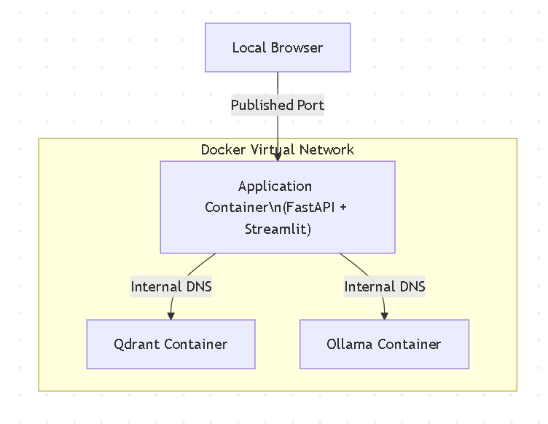
The project uses two collections:
First of all the main RAG collection stores chunk vectors and payload then uploaded files collection stores a small dummy vector and payload containing filenames and timestamps, used to list files in the UI. Payload fields stored per chunk as text, filename, cluster_id, uploaded_at.
(Enabling this allows filtering by the selected filenames)
3.5 Container architecture (services and networking)
All containers run on the same virtual network created by the compose setup. The application container reaches Qdrant using the internal service name, and reaches the LLM server the same way.
4. Implementation
4.1 Repository structure
My repo contains the following main files:
- app.py (FastAPI backend, ingestion, retrieval, streaming endpoint)
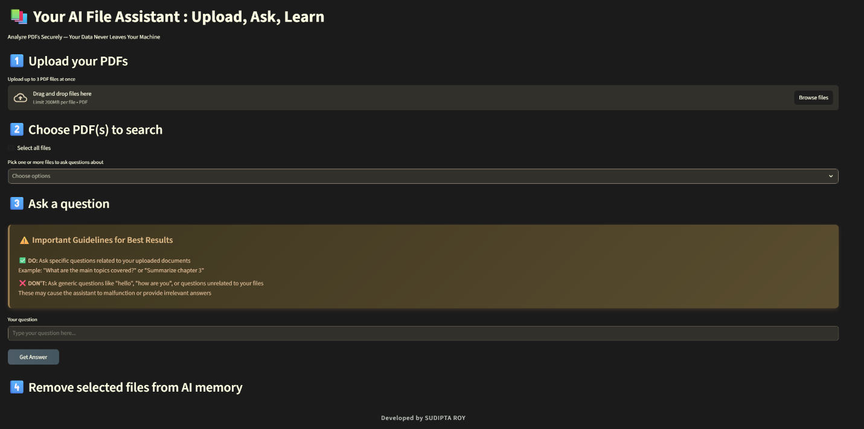
ui.py (Streamlit UI for upload, file selection, and streaming answers)
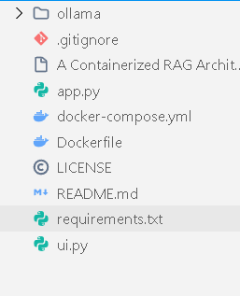
- Dockerfile (Builds the application image and pre downloads the embedding model) 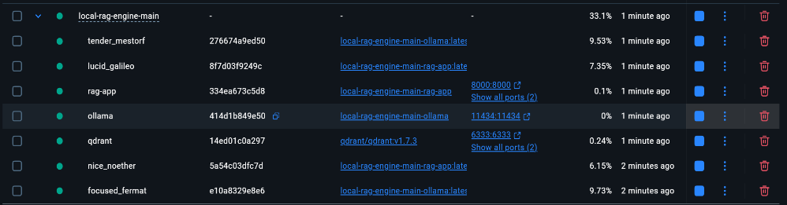
- requirements.txt (Python dependencies)
- compose file (Defines services for app, Qdrant, and Ollama)
- ollama folder (Build context for the LLM container)
4.2 Backend API implementation (FastAPI)
The backend defines endpoints:
- upload (Accepts PDF file and ingests it)
- query_stream (Accepts question and filenames, streams response)
- files (Lists uploaded filenames stored in Qdrant)
- delete_file (Deletes vectors and file index entries based on filename)
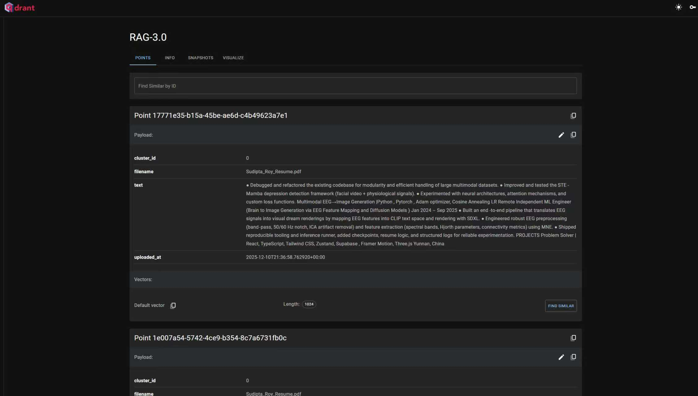
Code excerpt: API models
Explanation:
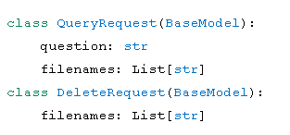
- QueryRequest allows multi file filtering, so the UI can query only selected PDFs
- DeleteRequest supports batch delete, which is more practical than deleting one file at a time
How this differs from simpler systems:
- Many demo RAG apps only support one document at a time
- This design supports multiple PDFs and user controlled filtering
4.3 Document ingestion pipeline (PDF, chunking, embedding, upsert)
Code excerpt: PDF extraction and chunking
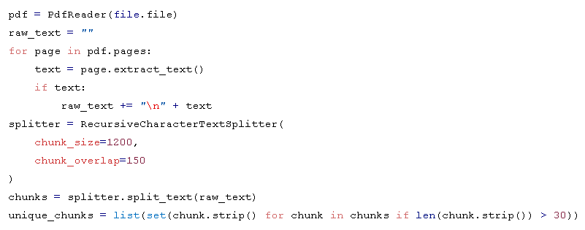
Explanation: it reads PDF pages and concatenates extracted text, then it splits text into overlapping chunks, it Removes tiny chunks and deduplicates exact duplicates.
Difference from other approaches:
Some systems embed entire PDFs as one block, which harms retrieval because the vector becomes too broad but chunking improves retrieval because vectors represent more focused meaning units, Overlap reduces “lost context” at chunk boundaries
Code excerpt: embedding generation and singleton pattern
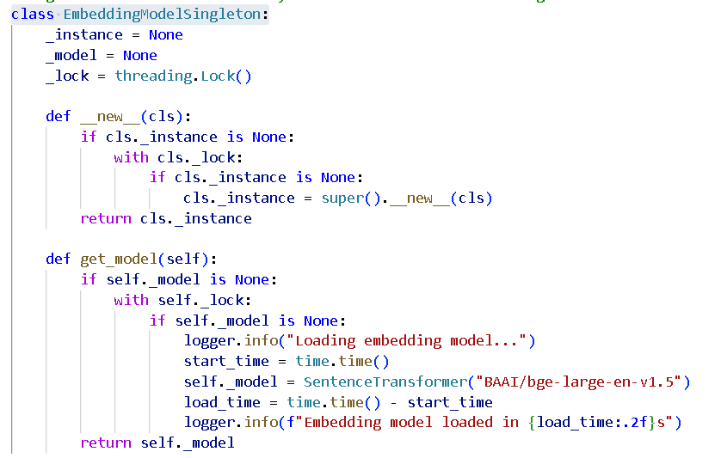
Explanation:
The model is created once, guarded by a lock, Concurrent requests do not reload the model fot that this reduces memory usage and improves response time.
Difference from many student projects:
A common mistake is to load the model inside every request handler and that causes slow requests and can exhaust memory
Code excerpt: storing vectors and payload in Qdrant
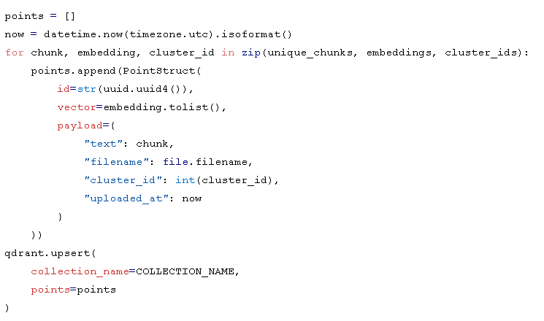
Explanation: Each chunk becomes one point in Qdrant, Payload stores metadata needed for filtering and UI features and Upsert writes all points efficiently
Difference from other storage patterns:
Storing only vectors without payload makes debugging harder and prevents filtering by filename and Payload enables a clean UX where the user picks which PDFs to search

4.4 Query pipeline (embedding, vector search, prompt building, streaming LLM answer)
Code excerpt: building query embedding and Qdrant filter
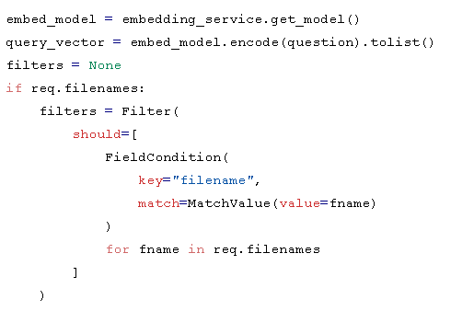
Explanation: Embeds the question into the same vector space as chunks and builds a metadata filter so results come only from chosen PDFs
Difference from simpler RAG demos: Many demos search the entire collection with no filter
And filename filtering makes the system behave more like a real product.
Code excerpt: vector search and prompt construction
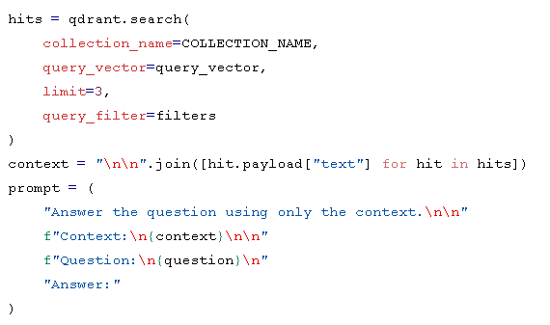
Explanation: This retrieves top 3 most similar chunks then concatenates them into a context block and forces the LLM to answer only from that context.
Why this matters: It reduces hallucinations compared to open ended prompts and It keeps answers grounded in the uploaded PDF.
Code excerpt: streaming answer to the client
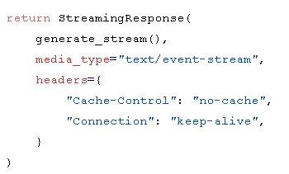
Explanation: The backend sends server sent events style streaming then the UI can render partial tokens as they arrive, this improves perceived speed
Difference from non streaming systems: Non streaming UIs feel slow because the user waits for the full completion but streaming gives instant feedback and a better experience
  - Frontend UI implementation (Streamlit)
The UI supports: It can Upload up to 3 PDFs , fetch list of uploaded filenames from backend moreover it also can select files or select all the user can ask a question, the UI Show streaming answer and the user can also delete selected files from “AI memory”. The whole process works locally.
Code excerpt: file upload and calling backend
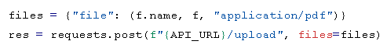
Explanation: Uses multipart upload so the backend receives a real file stream. It keeps the UI simple and focused
Code excerpt: streaming output rendering loop
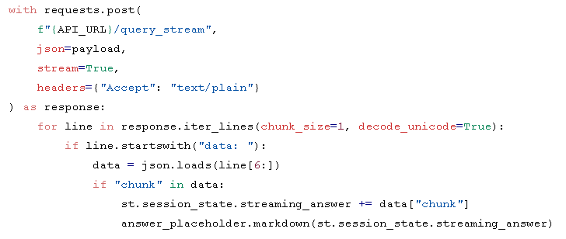

Explanation: Reads streamed lines progressively then updates the placeholder to show partial content after that it stores partial answer in session state so the UI can survive reruns.
Difference from basic Streamlit apps: Many Streamlit apps block until a request completes but this one shows incremental progress which feels faster
  - Dockerization (Dockerfile, compose design)
My Dockerfile does two important things: First it Installs Python dependencies then
Pre downloads the embedding model during image build to avoid long first request delay
Conceptual excerpt (sanitized to avoid restricted characters):
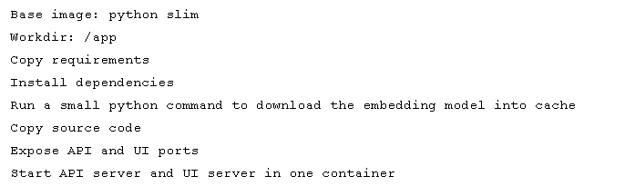
Explanation: Pre downloading the embedding model shifts the cost to build time for that the container starts faster at runtime. Running API and UI in one container is simpler for a student project, but I still meet the “three services” requirement because Qdrant and LLM are separate containers.
Difference from other student submissions:
Many projects download models at runtime, causing long first query delay and this project reduces that cold start problem by downloading at build time.
5. Results and Evaluation
5.1 Example queries and outputs
- Uploaded Document: “Machine Learning Fundamentals.pdf.”
• Query: “Summarize the main topics discussed in the document.”
• Output: The document presents an academic study that examines a specific research problem within its relevant field. It begins by outlining the background and significance of the topic, followed by a review of existing literature to establish the research gap. The study then describes the methodology and theoretical framework used to conduct the research. Results are presented and analyzed to evaluate the effectiveness of the proposed approach. The discussion interprets these findings in relation to previous studies. Finally, the document concludes by summarizing the key contributions, acknowledging limitations, and suggesting directions for future research.
- Performance Metrics
• Embedding Generation: ~2 seconds per document (average)
• Vector Storage and Retrieval: <1 second per query
• LLM Answer Generation: ~3-5 seconds for typical queries
7.3 Vector Similarity Examples
For each query, the system finds the top three most relevant chunks based on meaning, making sure the answers are based on the uploaded documents.
7.4 LLM Output Analysis
The answers generated are accurate, concise, and refer to the relevant document chunks. The streaming interface gives real-time feedback, which improves the user experience.
5.2 Performance observations (latency breakdown)
Your backend already logs timing for major stages. For the report, you can show a simple timing table based on real runs.
Suggested table:
Stage | What it measures | Typical observation
PDF read | parsing pages and extracting text | depends on page count
Chunking | splitting into chunks | usually quick
Embedding | encoding chunks | can be heavy on CPU
Upsert | writing to Qdrant | depends on chunk count
Query embed | encoding the question | usually quick
Vector search | nearest neighbor search | usually quick
LLM generation | producing the answer | depends on model and prompt
  - Retrieval quality checks
Simple quality checks you can describe:
I have asked the same question with different wording and confirm retrieval still finds the right chunk. I have asked a question that is not answered by the PDF and confirm the system returns “no context found” or a cautious answer.I also tried selecting only one file and verify the answer does not pull content from other files.
6. Discussion
6.1 Challenges and issues
Common issues that this project design addresses:
- Cold start delay due to model download: I solved it by pre downloading the embedding model in the image build step
- High memory use if model reloads per request: I solved by the singleton model loader
- UI responsiveness: I Improved using streamed responses
- Multi document management: I Implemented through the uploaded files collection and filename filters
  - Why containerization helped
Containerization benefits seen here: I can use repeatable environment
Same Python version and dependencies each time moreover it clears service boundaries
App, vector DB, and LLM are separated. One compose command can bring up everything.
  - Tradeoffs and limitations
Running API and UI in one container is simpler but not ideal for scaling and exacting deduplication using a set only removes exact duplicates, not near duplicates, KMeans cluster id is stored but not currently used in retrieval logic, it is mostly metadata for analysis. The retrieval uses top 3 chunks, which might miss needed context for some questions
7. Conclusion and Future Work
This project delivers a full containerized RAG system with real deep learning components: transformer embeddings and an LLM generation step. It includes a complete pipeline from PDF ingestion to chunking, embedding generation, vector storage, semantic retrieval, and streamed UI output.
Future improvements:
I will add reranking for better retrieval quality and store chunk positions and page numbers for citations.
8. References
- FastAPI documentation: https://fastapi.tiangolo.com
- Streamlit documentation: https://docs.streamlit.io
- Qdrant documentation: https://qdrant.tech/documentation
- Sentence Transformers documentation: https://www.sbert.net
- LangChain text splitters overview: https://python.langchain.com/docs
9. Appendix
Screenshots: 